**Project Report Template**

1.Introduction

1.1 Overview

Sales force property management enables the realty managers to keep track of crucial data about financial & household properties incorporating associated cash flow, primary tenants, and occupancy rates.

*1.2 Purpose*

Property managers assist owners in creating budgets, advertise rental properties, qualify tenants and collect rent. They also comply with the local landlord and real estate board laws and maintain the property.

2. Problem Definition & Design Thinking

*2.1 Empathy Map*

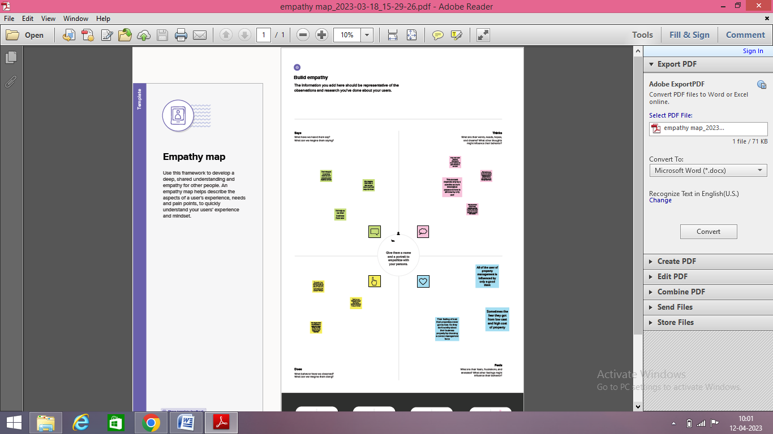

*2.2 Ideation & Brainstorming Map*

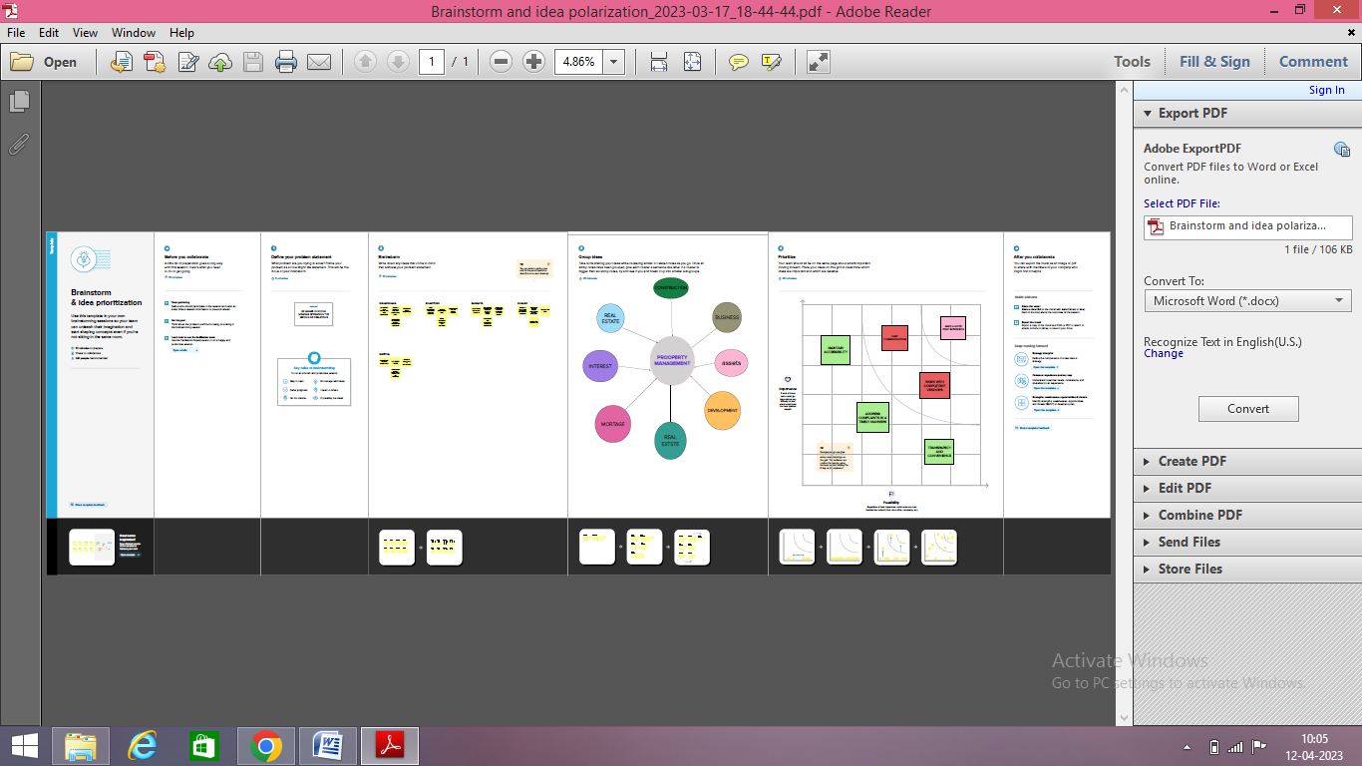

3. Result

*3.1 Data Model*

|  |  |  |  |  |
| --- | --- | --- | --- | --- |
| Object Name | Fields in the Object   |  |  | | --- | --- | | Field Label | Data Type | | |
| Buy | Discount | Percentage |
| Rent | City | Text |
| Loan | Annual Loan | Numbers |

*3.2 Activity & Screenshot*

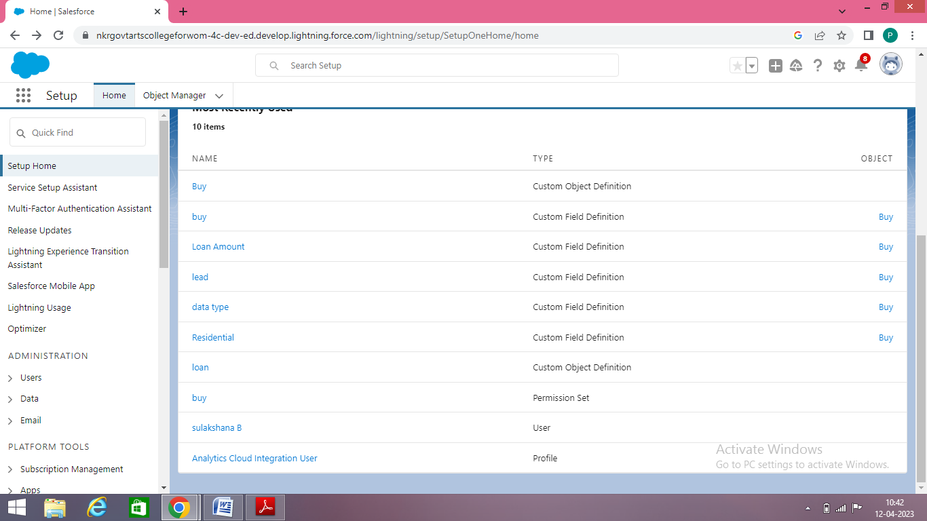

Sales force is your customer success platform, designed to help you sell, service, market, analyze, and connect with your customers.

*4. Trailhead Profile Public URL*

#### Team Lead :

Sulakshana B : https://trailblazer.me/id/sulab15

### Team Members :

Shanthini M : https://trailblazer.me/id/shanm212

Saranya N : https://trailblazer.me/id/saran651

Shalini V : https://trailblazer.me/id/shalv37

Swetha N : https://trailblazer.me/id/swetn13

5. Advantages

Time and energy for you: This will give you the peace of mind of knowing that your property is well taken care of.

Experience in the industry : Property managers have also studied fair housing laws and local laws that can affect landlords and tenants.

Tenant retention : Many property management companies use software that provides tenants with an easy to navigate site through which they can make routine requests, pay their rent, and directly communicate with their property manager.

*Disadvantages*

Loss of control : A property management company will hire its own employees, screen and approve tenants without your input, and may even make superficial changes to the property in the course of conducting maintenance or upgrades.

Expense : For the budget conscious property owner, hiring a property manager may feel like an unnecessary expense.

Finding a reliable property manager : You’ll want to take the proper steps to make sure you’re hiring the best property manager to oversee your rental property.

6. Applications

Maintenance Management & Tracking

Tenant Applications & Screenings

Online Payments

Contact Management

Advertising & Marketing

Financial Management

7. Conclusion

This sales technique consists in implying that the potential buyer is going to the purpose of sales force training is to make salespeople successful.

8. Future Scope

Sales force certifications are an excellent approach to developing technical knowledge and skills in the world’s most popular CRM platform.